Module 3 Project: Forecasting Financial Time Series

Dhairyav Jatin Shah

College of Professional Studies, Northeastern University

Professor: Zhi(Richard) He

March 16, 2023

**Introduction**

The stock market is a dynamic, ever-evolving environment that can be challenging to forecast. Accurate stock price predictions are crucial for making well-informed judgments. In order to anticipate the prices of two well-known stocks, Netflix, Inc. (NFLX) and Amazon.com, Inc. (AMZN), for the upcoming year, we will evaluate historical data for the two companies. Using increasing values of the smoothing parameter, we will apply exponential smoothing in Part 1 to forecast both prices for the upcoming time. To find the value of that produces the most accurate forecast for each stock, we will compute the MAPE (Mean Absolute Percentage Error) of each forecast. Then, by altering the trend parameter, we will perform adjusted exponential smoothing and compute the MAPEs to identify the values of that produce the most accurate forecasts. In Part 2, we will forecast the prices of both stocks for the following ten periods using a weighted moving average and linear trend. To assess the effectiveness of this strategy, we will contrast the predicted values with their actual "Close" values on those precise days. Moreover, we will compute the MAPEs for the same time frames. The stock prices for the upcoming 10 periods will be predicted using simple regression in Part 3. To ascertain whether the regression model is appropriate for the provided data, we will do a residual analysis. By creating a normal probability plot and running a Chi-square test to determine if the residuals are normally distributed, we may determine if they are independent, homoscedastic, and independent. Lastly, in Part 4, we will compute the MAPEs for the same time periods using the most recent price as a baseline model. To identify the method or ways that outperform the baseline model, we will compare the MAPEs of all the forecasting techniques. We intend to learn more about different forecasting techniques and how accurate they are at anticipating stock values through this study.

**Part 1**

1. In this research, we examine the historical stock prices for Amazon.com, Inc. (AMZN) and Netflix, Inc. (NFLX) over a year's worth of 252 trading days. For both time series in Part 1, we begin by creating a straightforward line plot to look for any seasonal, irregular, or trendy patterns. Observing the line plots for NFLX and AMZN, we notice that both stocks have been generally increasing in value over the period, with some fluctuations. AMZN seems to have a steadier increase in value over time, while NFLX has more frequent fluctuations in value. Additionally, both stocks have experienced a significant dip in value around the month of march. Both the stocks also show an increase in the 3rd Quarter of the year.

We don't see any obvious seasonal patterns in the price behavior of either stock when it comes to seasonal behavior. When it comes to irregular behavior, both stocks' values appear to experience some spikes and dips that don't appear to adhere to any discernible pattern or trend. Largely, the line plots reveal that both stocks have demonstrated an upward trend with some variations and irregular value declines.

1. In this section, we use exponential smoothing with smoothing parameters of 0.20, 0.40, 0.60, and 0.80 to forecast the prices of NFLX and AMZN for period 253. The smoothing parameter that produced the most accurate forecast for each stock is then determined by calculating the MAPE (Mean Absolute Percentage Error) for each forecast.

For NFLX, the MAPEs are correspondingly **3.00%, 2.32%, 2.08%, and 2.03%** and the MAPEs for AMZN are **2.80%, 2.12%, 1.90%, and 1.80%,** respectively, for α values of 0.20, 0.40, 0.60, and 0.80. The forecasted value of NFLX stock for period 253 is **522.31, 524.14, 525.05, and 525.34,** and that of AMZN stock for period 253 is **162.05, 163.65, 164.38, and 164.53,** respectively, for α values of 0.20, 0.40, 0.60, and 0.80.

According to the MAPEs, we can see that the projection for both stocks produced by the α value of 0.80 has the lowest MAPEs and has proven to be the most accurate. This means that the most recent observations are weighted more strongly in the projection, which is fair given that the stocks have seen an overall rising trend over the period.

1. We will now employ an adjusted exponential smoothing technique to increase forecast accuracy by taking trend information into account after performing exponential smoothing on the stock prices of Netflix and Amazon. We will apply the adjusted exponential smoothing with successive values of β (0.20, 0.40, 0.60, and 0.80) for both stocks using the exponential smoothing forecast with α = 0.60 generated in the preceding section.



Similarly, after performing adjusted exponential smoothening using the α value = 0.60 we obtain the following values. For NFLX, the MAPEs are correspondingly **2.09%, 2.07%, 2.07%, and 2.17%** and the MAPEs for AMZN are **1.84%, 1.81%, 1.80%, and 1.82%,** respectively, for β values of 0.20, 0.40, 0.60, and 0.80. The forecasted value of NFLX stock for period 253 is **525.87, 526.14, 526.14, and 525.75,** and that of AMZN stock for period 253 is **165.08, 165.26, 165.13, and 164.75,** respectively, for β values of 0.20, 0.40, 0.60, and 0.80. Based on the lowest MAPE, we then calculate the value of that has produced the most precise forecast for each stock. According to our analysis, the value of **β = 0.60** has produced the best accurate estimate for Netflix, with a **MAPE of 2.07%**. Similarly, Amazon's forecast accuracy has been best at **β = 0.60, with a MAPE of 1.80%.** Since both stocks' stock prices showed a substantial upward or downward trend throughout the observed period, I believe that a higher value **β** of generated the most accurate forecast for both stocks.

**Part 2**

1. We projected the values of both stocks using a 5-period weighted moving average approach for periods 1 through 100. For the most recent period, 0.30 for the most recent period t-1, 0.25 for t-2, 0.20 for t-3, 0.15 for t-4, and 0.10 for t-5. The observed value for period 101 served as the foundation for a linear trend, which we then utilized to predict the prices of both stocks for periods 253 through 262. The projected values and the actual values for both the stocks are given in the table below. We can see that there is a significant amount of disparity between the actual and predicted values. We confirm this by calculating the MAPE for these values.



1. After we have calculated the MAPE’s of the above forecasted values we can see that the mean absolute percentage error for both the stocks is high. The MAPE for AMZN is 6.36% and for NFLX is 3.44%.



**Part 3**

1. We must first plot the stock values against the time periods (1 through 252) and compute the regression line before we can apply simple regression to estimate the prices of both stocks for periods 253 through 262. The equation for both the stocks of Amazon and Netflix is given below. We obtained the equation for both the stocks using 2 methods, one is the graphical method where we plot the stock prices in a scatter plot and draw a trend line as shown in the figure below and another way is by using the inbuilt excel functions called the SLOPE and INTERCEPT as shown in the table below.



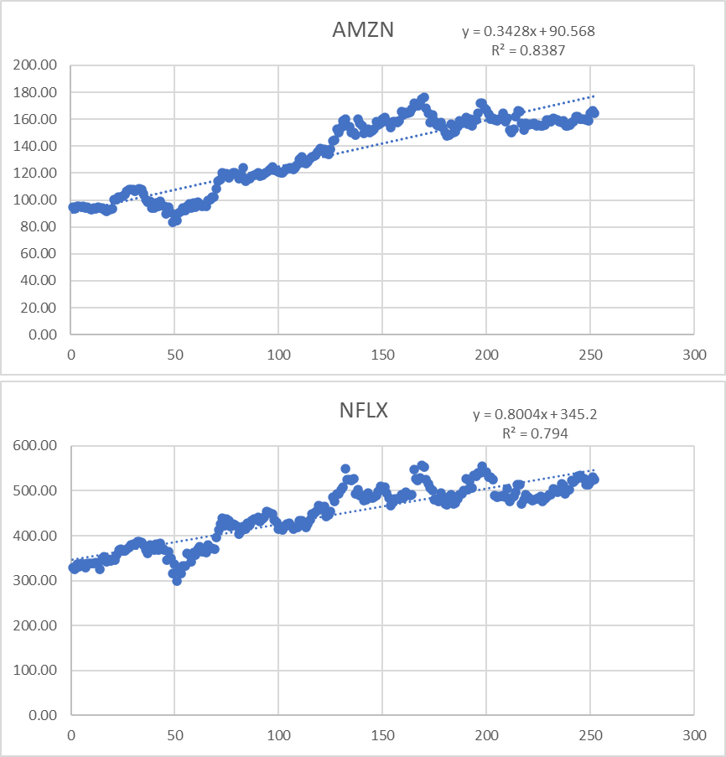

Using these equations we predict the stock prices for Amazon and Netflix from periods 1 through 262. Next we calculate the MAPE’s for periods 253 through 262.



The table above demonstrates the MAPE values from periods 253 through 262. We can see that for Amazon the MAPE value is 12.95% and for Netflix MAPE is 8.05%. The observed MAPE values for both the stocks is very high. This could be caused by a number of things, including a bad fit between the data and the linear regression line, non-linearity in the data, or the existence of outliers in the data. It can also suggest that other forecasting techniques should be employed if the linear regression model is inappropriate for the data.

1. We must test the following assumptions to see whether regression is appropriate to implement for each stock:
   1. Residual independence: The residuals should be entirely independent of one another. By plotting the residuals against the time intervals and searching for any patterns or trends, we can verify this. From the below graph for Netflix there doesn't seem to be any obvious pattern or trend in the residuals over time, according to the graph. Hence, it is plausible to conclude that the residuals are independent. Similarly for Amazon, we can see that there is a subtle patter formation observerd over time. Hence, we can say that thr residuals for Amazon might not be independent.

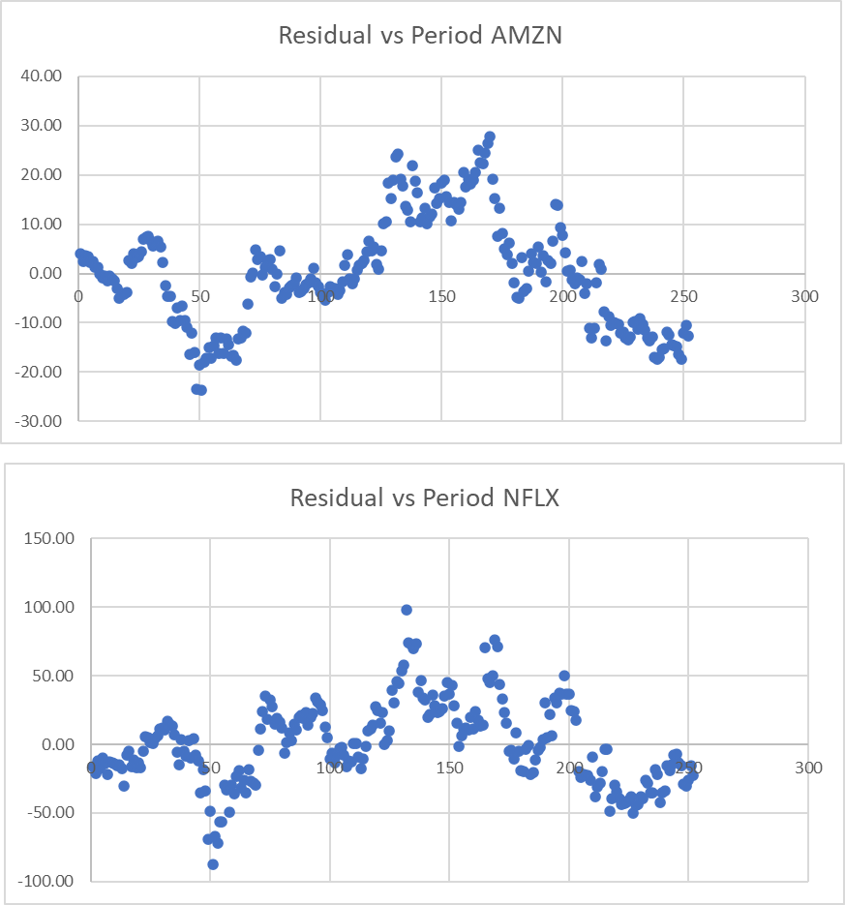

* 1. Homoscedasticity of residuals: The residuals must have constant variance at all levels of the independent variable if they are to be homoscedastic (time periods). By displaying the residuals against the expected values and searching for any patterns or trends, we will verify this. From the given plot below for Netflix, we can see a random pattern but no describable trend which implies that the residuals are homoscedastic. Similarly is case for Amazon as well but even if the patter is random there is a small trend that can be observed, hence we can say that the residuals for Amazon are not homoscedastic.

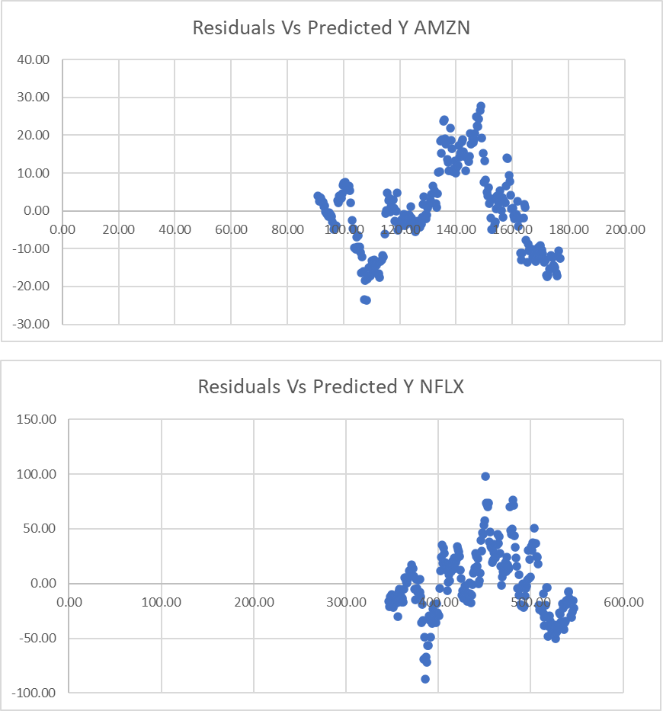

* 1. Residual normality: The residuals should follow a normal distribution. By doing a Chi-square test for the residuals' normality and generating a normal probability plot of the residuals, we can verify this. First we plot the normal probability plot in the

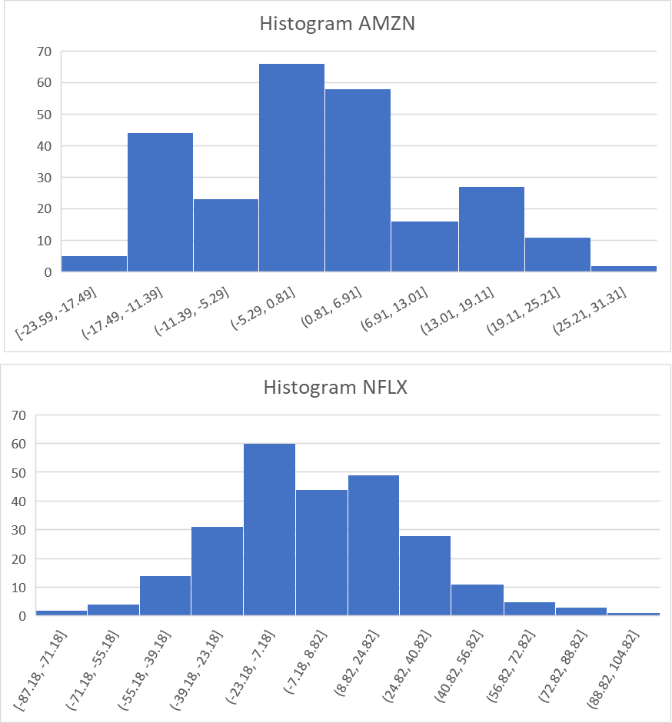

form of a histogram. Here we an observe that for Amazon the distribution is not normal and not Netflix the distribution is somewhat normal. Hence we can say that residuals for Amazon are not normally distributed but for Netlfix they might be distributed normally. Next we also plot the normality probabilty plot for residuals, we can see the scatterplot above, for Amazon we can see that the residuals don’t follow a straight line, which might state that the residuals are not normally distributed, whereas when we look at the Netflix chart we can see a straigh line of residuals which states that the residuals are normally distributed. We can confirm this by performing a goodness of fit test on both stock’s residuals.

To perform Chi-squared Goodness of Fit Test, we first start by stating the null and alternative hypothesis.

Null hypothesis: The residuals are normally distributed.

Alternate hypothesis: The residuals are not distributed normally.



To perform Chi-squared Goodness of Fit Test, we then use the standardized residual values to calculate the Min, Max, Sample Size, Range, Bin, Class Width, Mean and Std Dev as shown in the above table. Next using these values we calculate the upper limit, lower limit, probabilities, expected and observed frequencies and the chi-sq values. Which will be used in performing the test. Below both the tables show the

required values to perform the test.



Upon performing the chi-squared goodness of fit test, we can see for the Stock Amazon our degree of freedoom is 15, test-statistic is 50.54 and the obatined p-value is 0.000010. We know that our p-value is less than our alpha value 0.05, Hence we can reject our null hypothesis and confirm that Amazon residuals don’t follow normal distribution. Next, for Netflix we can see that our degree of freedom remains same as 15, test-statistic is 13.78 and p-value is 0.54. Here can see that our test-statistic is smalled compared to the test-statistic of Amazon also the p-value obtained is greater than that of our alpha value that is 0.05. Hence, we fail to reject our null hypothesis and we can confirm that we have enough evidence to conclude that residuals for Netflix are normally distributed.

**Part 4**

Based on our data, we determined the MAPEs for periods 253 through 262, using the most recent price as the current price projection for periods 2 through 262. The forecasting technique(s) that can outperform the benchmark were then assessed by comparing these MAPEs to the benchmark. The benchmark set for MAPEs for both the stocks are as follows



Based on our benchmark value, we can now analyze and check which methods can outperfom the benchmark. From our analysis earlier we can see that 5-period weighted average method dervied MAPE values 6.36% and 3.44% for amazon and netflix respectively. The results indicate that 5-period weighted average method had the lowest of all the methods we use to predict the prices but it did not outperform the benchmark. This suggests that this forecasting method is a more accurate predictor of future stock prices for this particular dataset.

Question:

The investor's risk tolerance, investment objectives, and market expectations are primarily what determine how much of an investment should be allocated to each company (AMZN and NFLX). One approach to deciding the allocation is to consider the historical performance of the stocks and their expected future performance which we have performed in this assignment. For example, from regression we can see that netflix had a greater slope compared to amazon, which indicated that the increase in netflix stocks would be comparitively greater than that of Amazon. But when we plot the values over the period of time to analyze the trend we can see that amazon had a gradual increase without a lot of irregualar activities where as netflix had a lot of irregular cycles of ups and downs. Hence we can say that if the investor is open to high risk and volatility then there is a option to give netflix a higher amount of shares and amazon a lower amount of shares. Where P can be 40% and Q is 60%. Where as if the investor is someone who doesn’t want a high risk and steady increment in the profits then one can have higher share allocation for amazon and a lower allocation for netflix. Where the allocation of P can 75% and Q 25% respectively.

**Reference**

1. *Lesson 3-2 — Forecasting Methods* <https://northeastern.instructure.com/courses/131431/pages/lesson-3-2-forecasting-methods?module_item_id=8233645>
2. *Module 3 Lab* <https://northeastern.instructure.com/courses/131431/pages/module-3-lab-1-forecasting-of-time-series?module_item_id=8233658>
3. *Lesson 3-3 — Regression Analysis* <https://northeastern.instructure.com/courses/131431/pages/lesson-3-3-regression-analysis?module_item_id=8233664>
4. Ayon.S (Jan 2023) *How to Calculate Trend Adjusted Exponential Smoothing in Excel* <https://www.exceldemy.com/calculate-trend-adjusted-exponential-smoothing-in-excel/>